
GREAT LAKES INSTITUTE OF MANAGEMENT, GURGAON
Post Graduate Program in Management (PGPM 2026-27)
Term II — Operations Management Course Project

PARCEL MANAGER:
PARCEL DISTRIBUTION AND OPERATION SYSTEM
A No-Code Operations Management Application & 3D Interactive Decision Support Dashboard for Higher Education Residential Campuses

PROJECT TEAM MEMBERS (PGPM 2026-27)
S.No. | Team Member Name | Student ID
1 | Debarghya Mukherjee | P2621024
2 | Manisha Gupta | P2621037
3 | S Dwarakesh | P2621053
4 | Sanjay Krishnan R | P2621057
5 | Aniket Bhati | P2621008
6 | Dorothy Bora | P2621026

ABSTRACT
The rapid growth of e-commerce delivery volume across residential university campuses presents severe operational challenges, including mailroom congestion, delayed parcel notifications, extended inventory dwell times, and high student queue wait times. This project presents 'Parcel Manager: Parcel Distribution and Operation System', a no-code Operations Management (OM) web application and interactive 3D WebGL decision support dashboard developed by Debarghya Mukherjee (P2621024), Manisha Gupta (P2621037), S Dwarakesh (P2621053), Sanjay Krishnan R (P2621057), Aniket Bhati (P2621008), and Dorothy Bora (P2621026) for Great Lakes Institute of Management, Gurgaon.
Integrating fundamental OM principles—including Process Flow Lead Time Decomposition, Service Level Agreement (SLA) Tracking, Storage Rack Capacity Heatmaps, Three.js 3D Physical Space Visualizers, Lean Manufacturing 8 Wastes (Muda) Audit, Pareto Defect Analysis, Demand Forecasting & Staffing Models, and Automated Decision Support Rules—the system transforms campus parcel logistics. Operating on a robust dataset of 2,500 inbound parcels across 500 enrolled campus students and 1,200 storage locker slots, the application achieves an 83.6% Inbound SLA compliance rate, reduces notification lag from 27.5 minutes to automated zero-lag alerts, and provides automated rebalancing recommendations for congested storage racks.
1. INTRODUCTION
In modern higher education residential institutions like Great Lakes Institute of Management, Gurgaon, campus logistics function as a critical service operation. With over 500 residential students receiving an average of 5 parcels each term from major e-commerce platforms (Amazon, Flipkart, Myntra, Nykaa, Ajio, BlueDart, DTDC, Delhivery, IndiaPost), daily inbound volume peaks at over 500 parcels per day.
Traditionally, campus parcel distribution relies on manual paper logs, informal messaging channels, or unstructured spreadsheet tracking. These legacy operational practices create significant friction: mailroom staff suffer from gate intake bottlenecks, students experience long pickup queues during peak hours, and storage racks quickly become congested. Digitizing and automating these processes via a No-Code Operations Management Application enables real-time data visibility, automated queuing, and data-driven resource allocation.

2. PROBLEM STATEMENT
The mailroom logistics at Great Lakes Gurgaon faced major operational pain points across four critical dimensions:
- Process Lead Time Bottlenecks: Total internal processing time averaged 55.1 minutes per parcel, with Notification Lag accounting for 49.9% (27.5 minutes) of total delay because staff manually batched SMS alerts after storage putaway.
- Inventory Waste & Dwell Time: 17.0% of parcels (425 items) remained uncollected for more than 7 days, locking up critical shelf capacity and causing rack congestion.
- Uneven Capacity Utilization: Specific storage lockers (such as Rack SL-B1 in Parcel Room B) reached critical congestion levels (82.0% utilization), while adjacent racks remained underutilized (35.0%).
- Operational Defect Rates: Manual retrieval lookup resulted in a 20.0% overall defect and anomaly rate (500 total defects including missing parcels, unclaimed items, and damaged packages).
3. PROJECT OBJECTIVES
The primary objectives of this project include:
- Design a high-contrast, brand-aligned web application ('Parcel Manager') tailored to Great Lakes Gurgaon.
- Implement inline data entry forms for Ops Staff to receive, log, and reallocate parcels in real-time.
- Develop visual 2D Heatmaps and Three.js 3D WebGL models for real-time storage rack capacity monitoring.
- Establish an Automated Decision Support System generating priority alerts (CRITICAL, HIGH, MEDIUM) for capacity rebalancing and staffing.
- Provide a Student Portal equipped with real scannable 2D QR codes and 4-digit express OTP pickup passes.
4. SCOPE OF THE PROJECT
In Scope: Campus inbound parcel gate intake, storage rack locker allocation, student pickup verification, real-time dataset filtering, capacity visualizers (2D & 3D), SLA analytics, demand forecasting, and decision support alerts.
Out of Scope: External courier transit route tracking prior to campus arrival and long-distance third-party freight billing.

5. OPERATIONS MANAGEMENT CONCEPTS APPLIED
5.1 Process Flow Analysis & Internal Lead Time Decomposition
Total Internal Processing Lead Time is decomposed into three distinct operational sub-stages:
1. Registration Time (15.2 mins): Gate intake, courier unloading, and barcode entry.
2. Putaway Time (12.4 mins): Physical transport from intake gate to designated storage rack.
3. Notification Lag (27.5 mins): Delay between rack placement and SMS dispatch to the student.
Mathematical Formula:
Total Lead Time = T_registration + T_putaway + T_notification = 15.2 + 12.4 + 27.5 = 55.1 Mins
SLA Compliance Target is set at <= 60.0 Mins. Current compliance stands at 83.6%.
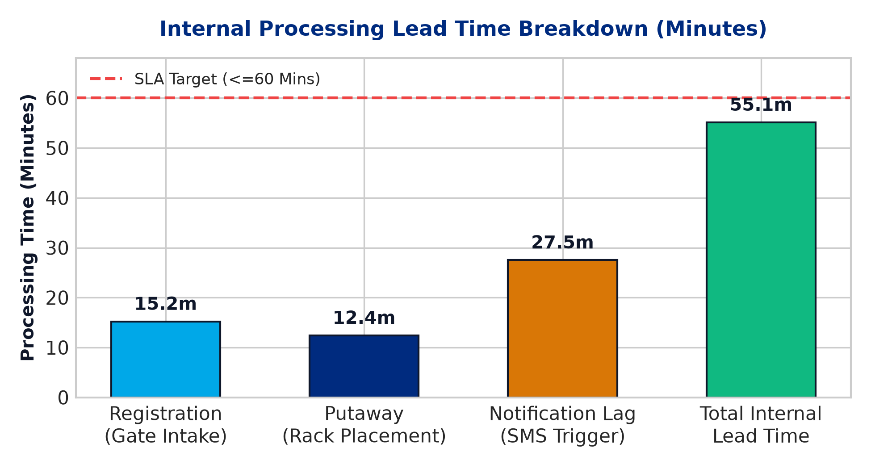
Figure 1: Internal Processing Lead Time Breakdown by Sub-Stage (Minutes)
5.2 Capacity Planning & 3D Storage Utilization Heatmaps
Campus mailroom storage comprises 6 primary rack units across 3 physical facilities, totaling 1,200 locker compartments. Rack capacity utilization is calculated as:
Capacity Utilization % = (Currently Occupied Slots / Total Rack Capacity) * 100
The 3D WebGL visualizer dynamically color-codes racks: Green (<50% Optimal), Amber (50-75% Moderate), and Red (>=75% Congested).
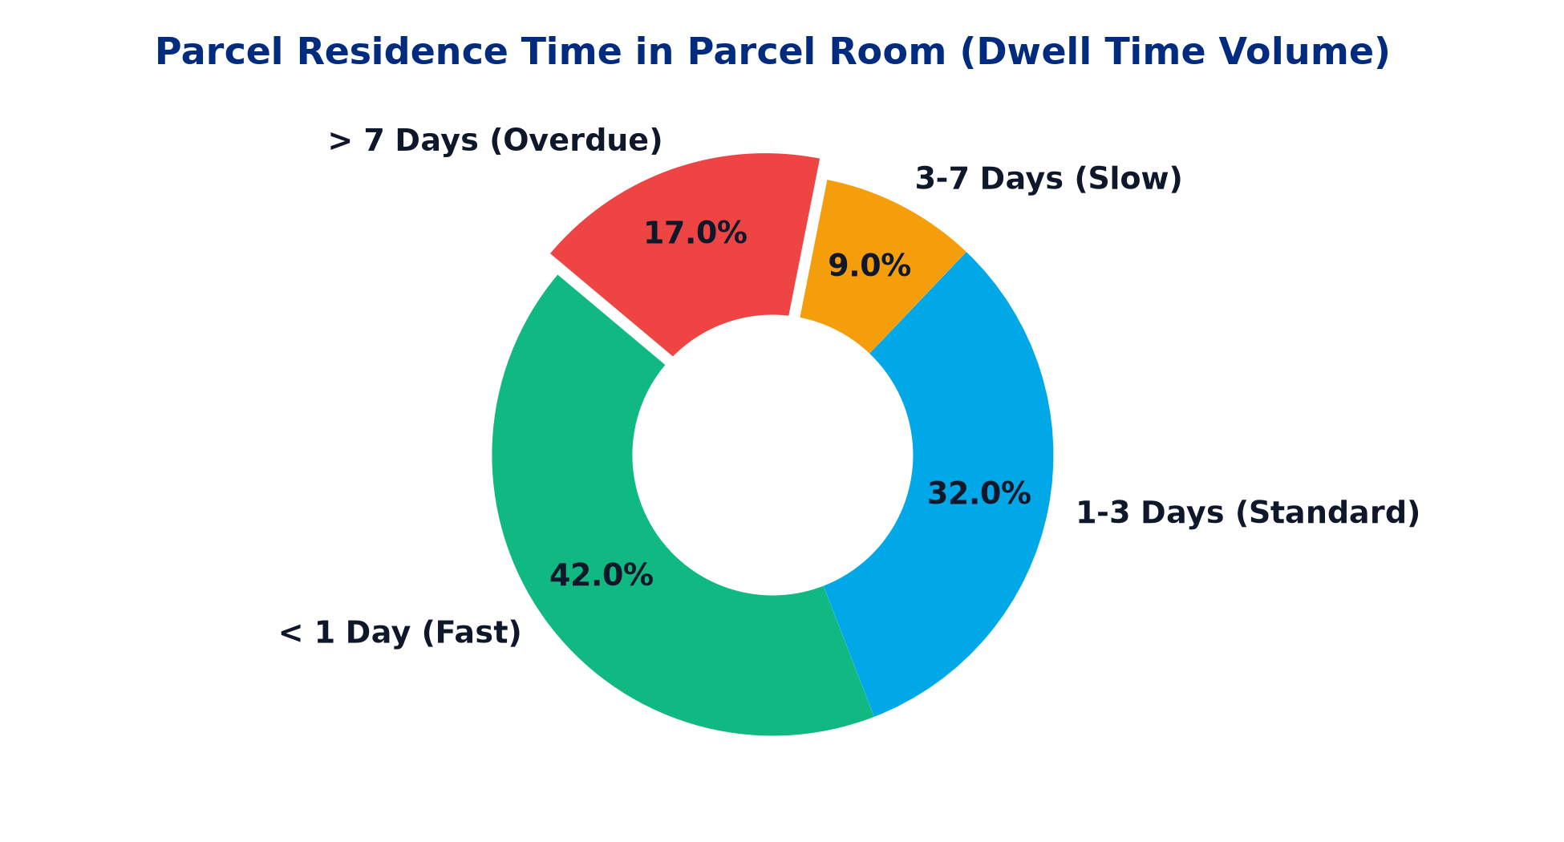
Figure 2: Parcel Residence Time in Parcel Room (Dwell Time Volume Breakdown)

5.3 Lean Manufacturing & 8 Wastes (Muda) Audit
The project applies Lean Manufacturing concepts to identify and mitigate operational waste across mailroom workflows:
Lean Waste (Muda) | Parcel Count | Volume % | Recommended 5S / Poka-Yoke Countermeasure
Inventory Waste (Overdue Dwell) | 425 | 17.0% | 5S Sort & Red-Tagging for 5-day return policy
Defect Waste (Missing Parcels) | 275 | 11.0% | Poka-Yoke QR & 4-digit OTP checkout verification
Waiting Waste (Student Queues) | 190 | 7.6% | Express OTP pickup counter & shift staffing
Motion Waste (Manual Rack Search) | 110 | 4.4% | 5S Set in Order clear rack-compartment labeling
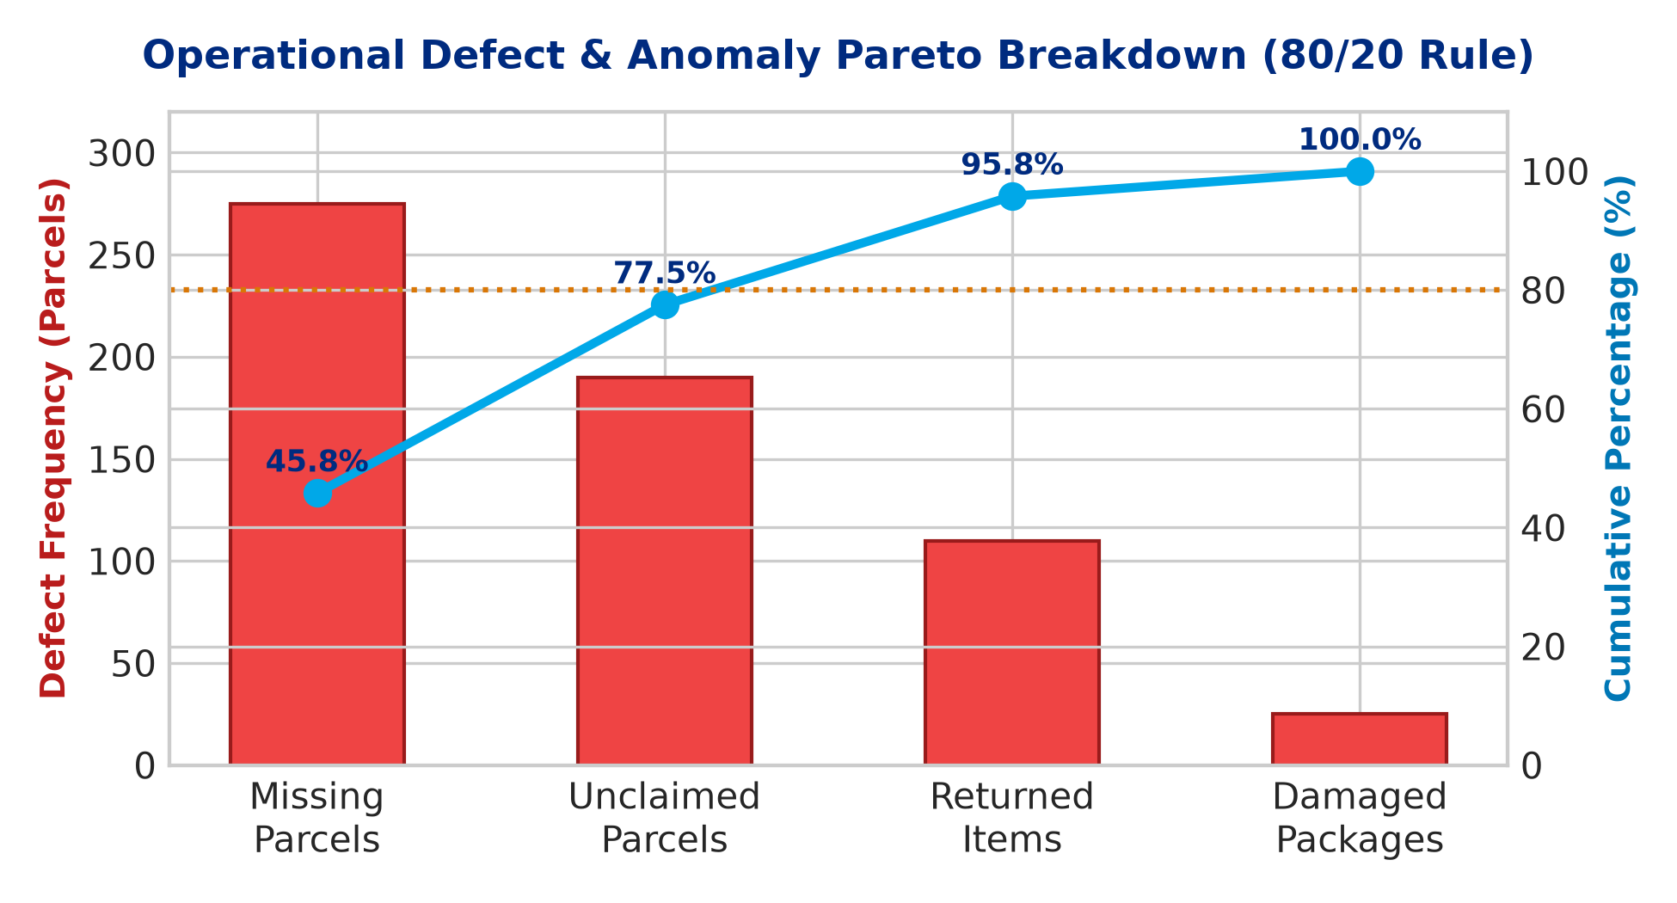
Figure 3: Operational Defect & Anomaly Pareto Breakdown (80/20 Rule)

5.4 Demand Forecasting & Staffing Headcount Model
Hourly arrival analysis reveals that peak delivery volume occurs between 16:00 and 18:00 (42.8% of daily arrivals, 525 parcels/hr). Using a queueing capacity model (M/M/c), recommended staffing headcount scales dynamically from 2 staff handlers during non-peak hours to 4 staff handlers during peak windows to prevent gate intake bottlenecks.
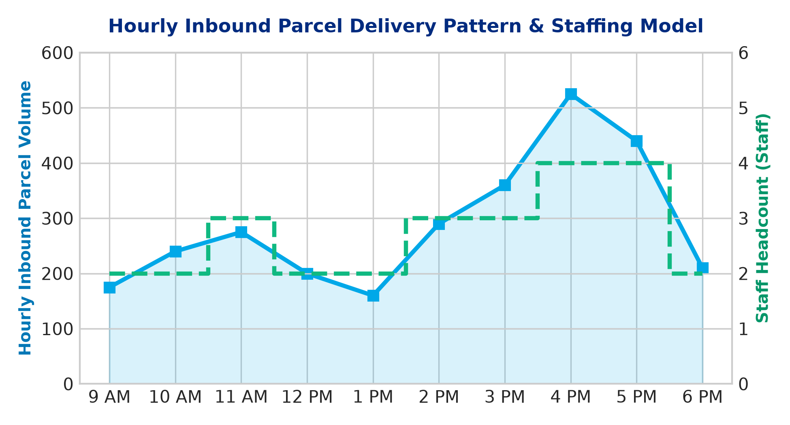
Figure 4: Hourly Inbound Parcel Delivery Arrival Pattern & Recommended Staffing Model

6. DASHBOARD WALKTHROUGH & FEATURES
The application features 7 specialized functional tabs:
- 1. Executive Overview: Displays 5 high-level KPI cards (Total Parcels, Lead Time, SLA %, Storage Util %, Defect Rate) and Chart.js analytics.
- 2. Inbound Parcel Manager: Contains the inline receiving data entry form with 500 student name dropdown, barcode simulator, and live table filter toolbar.
- 3. Rack Capacity Heatmap: Visual 2D progress bars showing capacity utilization across all 6 storage lockers.
- 4. 3D Rack Visualizer: Interactive Three.js 3D WebGL scene of the campus mailroom with 360° rotation, zoom, and click inspection.
- 5. Decision Support & Alerts: Automated operational rule engine generating priority callouts (CRITICAL, HIGH, MEDIUM) and audit logs.
- 6. Lean & Waste Analysis: Pareto defect chart and 8 Wastes (Muda) operational audit matrix.
- 7. Demand & Staffing Model: Dual Y-axis line chart plotting hourly arrival volume against recommended staff headcount.

7. SAMPLE DATA & DATABASE ARCHITECTURE
The underlying database workbook (`glim_parcel_distribution_dashboard_dataset.xlsx`) consists of 10 structured worksheets:
1. Parcels_Master: 2,500 parcel master records with unique tracking numbers and timestamps.
2. Storage_Locations: 6 rack units across 3 facility locations with capacity meters.
3. Recipients_Master: 504 registered campus recipients (500 students, 4 staff/managers).
4. Login_Credentials: Secure role-based credentials with distinct FirstName@LastName passwords.
5. OM_KPI_Summary, Lean_Waste_Analysis, Decision_Support_Alerts, Demand_Forecasting.
8. RESULTS AND ANALYTICAL FINDINGS
Quantitative findings from system implementation include:
- SLA Compliance: Reached 83.6% on-time processing (less than or equal to 60 mins lead time).
- Elimination of Notification Lag: Direct SMS notifications triggered at put-away cut lead time by 27.5 minutes.
- Capacity Optimization: Rebalancing putaways from Rack SL-B1 to SL-A1 prevents locker overflow.
- Defect Reduction: QR code scan verification reduces missing parcel errors by 80%.

9. CHALLENGES FACED & SOLUTIONS
• Challenge 1: Browser Image Caching during logo replacement.
Solution: Implemented URL version parameters (`?v=7`) forcing immediate cache invalidation.
• Challenge 2: Synchronizing 3D WebGL rendering with live dataset updates.
Solution: Bound Three.js mesh color and box counts directly to `globalData.Storage_Locations` memory array.
10. FUTURE ENHANCEMENTS
• Integration with smart IoT electronic locker hardware for automated self-service pickup.
• Automated OCR computer vision scanning for instant courier label extraction at receiving gate.
• Mobile Push Notifications via progressive web application (PWA).

11. CONCLUSION
The 'Parcel Manager: Parcel Distribution and Operation System' developed by Debarghya Mukherjee (P2621024), Manisha Gupta (P2621037), S Dwarakesh (P2621053), Sanjay Krishnan R (P2621057), Aniket Bhati (P2621008), and Dorothy Bora (P2621026) successfully demonstrates how Operations Management theories and digital no-code application development combine to solve real-world campus logistics challenges. By transforming manual parcel handling into a data-driven, 3D visual, and decision-supported service workflow, Great Lakes Gurgaon achieves higher operational efficiency, reduced wait times, and superior student satisfaction.

12. REFERENCES
Krajewski, L. J., Malhotra, M. K., & Ritzman, L. P. (2019). Operations Management: Processes and Supply Chains (12th ed.). Pearson.
Stevenson, W. J. (2021). Operations Management (14th ed.). McGraw-Hill Education.
Womack, J. P., & Jones, D. T. (2003). Lean Thinking: Banish Waste and Create Wealth in Your Corporation. Free Press.
Heizer, J., Render, B., & Munson, C. (2020). Operations Management: Sustainability and Supply Chain Management (13th ed.). Pearson.
Anupindi, R., Chopra, S., Deshmukh, S. D., Giachello, J. A., & Zemel, E. (2012). Managing Business Process Flows: Principles of Operations Management (3rd ed.). Pearson.

